King’s Business School, King’s College London

Cover Sheet for [7QQMM906 Environmental Economics] 24/25

|  |  |
| --- | --- |
| **Candidate ID:** | **AG08817**  **AG43395** |
| **Module Code:** | **7QQMM906** |
| **Module Name:** | **Environmental Economics** |
| **Word Count:** | **1839** |

Please complete the above candidate and module information and attach to the front of your answer sheet/submission or write your answers on the following page(s).

Where applicable students should clearly state the question(s) they are answering (e.g. Question 1, Part A) so it can be clearly identified for markers.

**DECLARATION BY STUDENT**

I understand what is meant by plagiarism/collusion and have signed at enrolment the declaration concerning the avoidance of plagiarism/collusion.

I understand that plagiarism and collusion is a serious examinations offence that may result in disciplinary action being taken.

I understand that I must submit work BEFORE the deadline, and that failure to do so may result in late submission penalties.

I understand that where a word limit is indicated, I should adhere to the word limit and failure to do so may result in penalties.

I understand that King's requires students to acknowledge any use of generative AI tools in coursework.

Please delete one of the statements below and attach this document to your assignment before uploading:

1. I declare that no part of this submission has been generated by AI software. These are my own words.

Note. Using software for English grammar and spell checking is consistent with Statement 1.

By completing this assessment, you acknowledge that you have read and understand the above. Please do not sign your name.

**Part I: Motivation and Data Context**

**a. Dataset Selection and Research Questions**

The main goal of this study is to analyze the economic roles of nuclear power and renewable energy in the global transition toward cleaner energy systems. As countries aim to reduce carbon emissions and enhance energy security, nuclear, wind, and solar power are widely recognized as key low-carbon energy sources in future energy systems (IPCC, 2022; IEA, 2023).

Among renewable energy sources, hydropower has traditionally been considered clean energy. However, its development is strongly constrained by geographical conditions, and in many countries, it has reached a mature technological stage. As a result, opportunities for further cost reductions and technological improvements are limited, making hydropower less suitable for analyzing dynamic changes in energy costs and substitution effects (IEA, 2021). In contrast, wind and solar energy have experienced rapid technological progress and significant cost reductions over the past decade. Their broad global data availability also makes them suitable for studying recent energy transition trends (IRENA, 2023).

Given these limitations, this study focuses on the relationship between economic development and energy expansion, as well as structural differences among low-carbon energy technologies. Therefore, the Energy Institute's Statistical Review of World Energy dataset and the World Bank's datasets on GDP per capita, energy imports, industrial structure, oil rents, political stability, and urbanization rates will be used in the research. Accordingly, two research questions are proposed.

**Research Question 1:**  
Does economic growth, measured by GDP, affect the development of nuclear, wind, and solar energy differently across countries?

Previous studies show that renewable energy investments are capital-intensive and closely linked to a country’s level of economic development and investment capacity (Sadorsky, 2009; Marques & Fuinhas, 2012). Nuclear power, by contrast, is often shaped by long-term national energy planning and policy commitments, implying a weaker response to short-term economic changes.

**Research Question 2:**  
Do nuclear, wind, and solar energy play different economic and structural roles within national energy systems?

Recent system-level studies emphasize that nuclear energy is often treated as a stable baseload technology rather than a short-term substitute for renewable energy based solely on cost competition (Nature Energy, 2022).

**b. Data Significance and Relevance**

The Environmental Kuznets Curve (EKC) hypothesis provides a key theoretical link between this study and environmental economics. The EKC suggests an inverted-U relationship between economic development and environmental degradation, where environmental quality initially worsens as income rises but improves after a certain income level is reached (Grossman & Krueger, 1995; Stern, 2004).

Environmental improvements in the later stage of the EKC are closely linked to structural changes in production and consumption, particularly the shift toward cleaner energy sources. Environmental economics also views environmental quality as a normal, and often luxury, good, meaning demand for cleaner environments increases with income (Kriström & Riera, 1996; Dasgupta et al., 2002). Wind and solar energy can therefore be seen as channels through which societies meet rising demand for environmental quality. Because these technologies are capital-intensive and often more costly without policy support, they tend to expand more rapidly in higher-income economies (Sadorsky, 2009; Marques & Fuinhas, 2012).

Nuclear energy occupies a unique position in this framework. Unlike wind and solar energy, nuclear power development is not mainly driven by market demand or consumer preferences. Instead, it depends heavily on centralized policy decisions, long-term planning, and national strategic considerations. A weaker relationship between nuclear energy expansion and GDP growth is therefore consistent with viewing nuclear power as a public or strategic asset rather than a market-driven response to rising income (MIT Energy Initiative, 2018; Nature Energy, 2022).

Since this study only roughly compares the economic benefits of three clean energy sources, the primary audience should be the public concerned about environmental issues, followed by energy policymakers, scholars in the field of energy economics, international organizations in related fields, and large energy companies.

**2. Part II: Technical Implementation**

**a. Coding Setup and Documentation**

Our coding is mainly divided into five sections: clean, merge, statistic table, 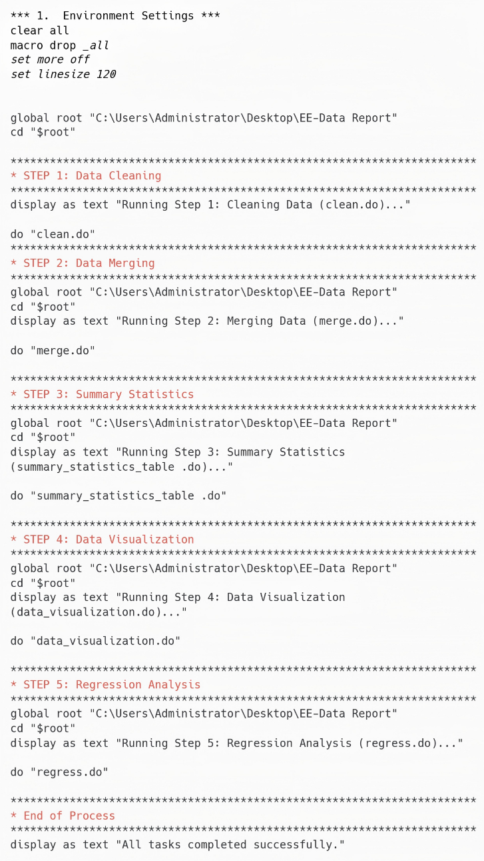visualization, and regression. The overall operation is controlled by a master do file.

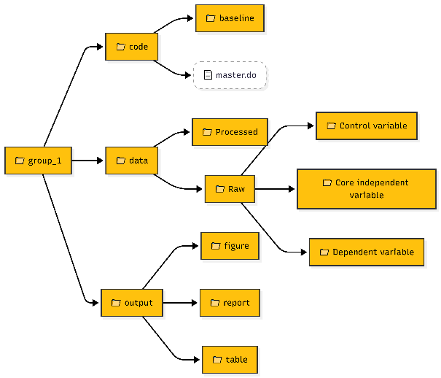**Figure 1**: Merge do-file structure

**Figure 2**: Folder organization

**b. Data Preparation and Management**

**Section 1: Cleaning and aggregation**

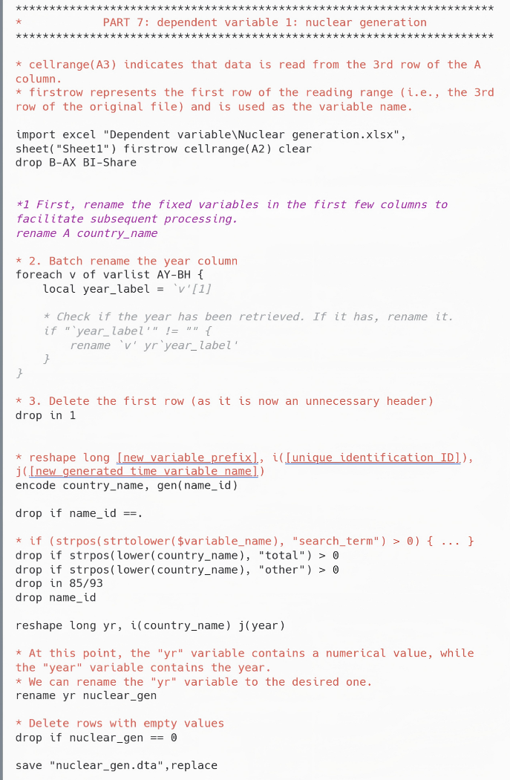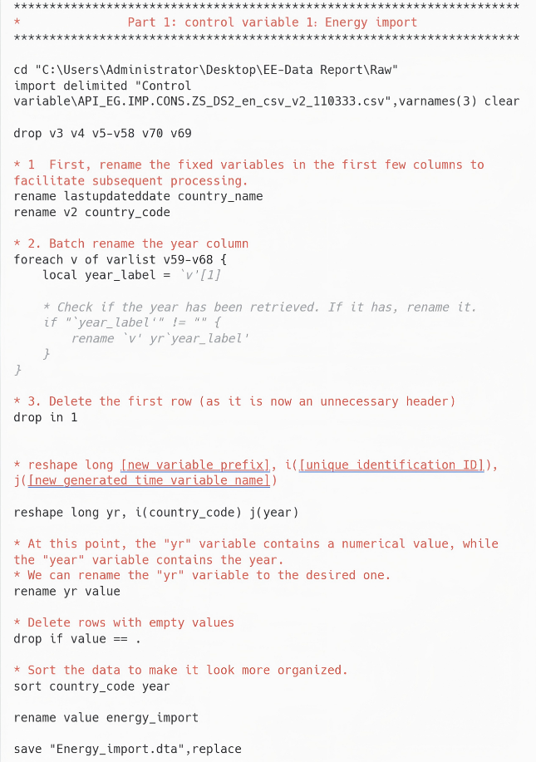The first six files and the last three have different data layouts and formats. Therefore, two different "clean do-files" were used.

**Figure 3**: Clean do-file (1) structure **Figure 4**: Clean do-file (2) structure

One important issue is the linguistic differences in country names within our dataset. To address the inconsistency in country names (differences between Chinese and English) during data processing, this study utilizes country codes as identifiers to extract and match corresponding Chinese labels from the “energy import” dataset, achieving standardization of country names and ensuring accurate merging of 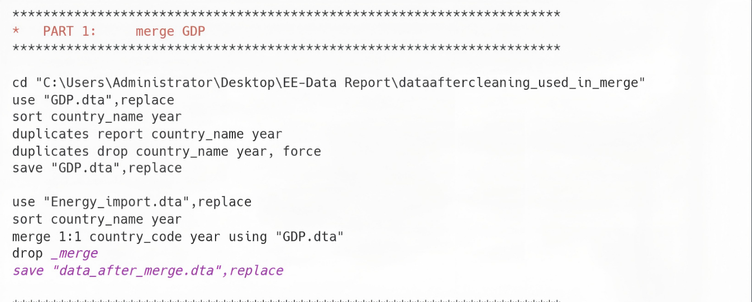subsequent datasets.

**Figure 5**: Merge do-file Problem solution

Apart from previous problem, most of the other problems were caused by wrong paths and spelling mistakes in the words, these errors were detected and corrected step by step.

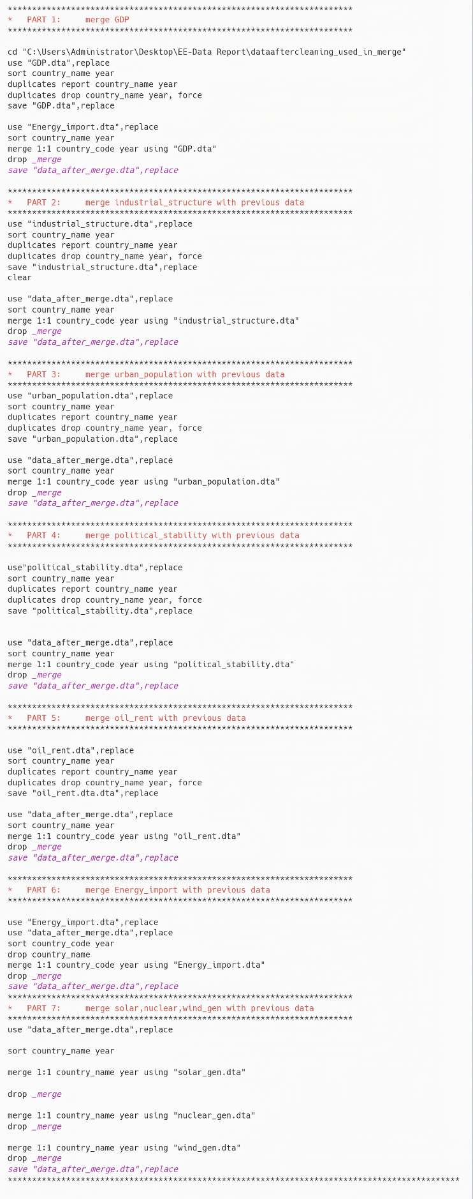**Section 2: Merging**

**Figure 6**: Merge do-file (1) structure **Figure 7**: Merge do-file (2) structure

This procedure guarantees that all control variables, along with the independent variable (GDP) and the dependent variable, are consolidated into a single table.

**3. Part III: Descriptive Analysis and Export of Results for Presentation**

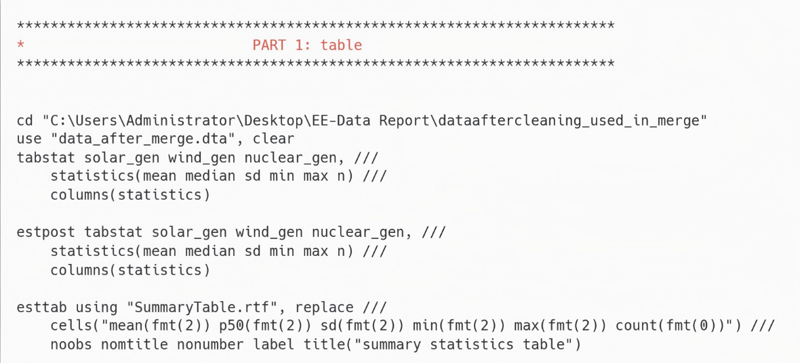**a. Summary Statistics Table**

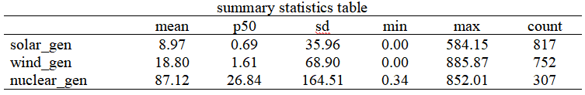**Figure 8**: Statistics table do-file

**Figure 9**: Statistics table

This table provides a direct comparison of the power generation of the three energy sources. In terms of average power generation, nuclear power generates significantly more electricity than wind and solar power, indicating that nuclear power production is more concentrated and large-scale. However, its median is 27, which is much lower than the average of 87 for solar and wind power. In terms of quantity (n), solar and wind power have more than twice the coverage of nuclear power. Overall, the energy transition development among countries is extremely uneven, with potentially huge differences in resources, policies, and technologies.

**b. Data Visualization and Exploration**

The visualization here is mainly aimed at providing an intuitive explanation for the previous "Summary Statistics Table" data.

**Distribution analysis**: 一張含有 文字, 螢幕擷取畫面, 圖表, 繪圖 的圖片

AI 產生的內容可能不正確。

**Figure 10**: Boxplots of three power generations

Nuclear power generation has a small and high-lying power generation capacity, meaning its output is very stable. Wind and solar power, on the other hand, are more volatile, with their power generation capacity mostly located at lower levels. This indicates their lower stability and greater variability. Electricity should not be judged solely by the amount of electricity it produces. Governments need to examine energy capacity markets to ensure that certain types of electricity can be stored when they are not immediately available (Joskow, 2011; IEA, 2022).

**Temporal and spatial patterns**:

一張含有 文字, 行, 繪圖, 圖表 的圖片

AI 產生的內容可能不正確。

**Figure 11**: Time series plots of three power generations

Solar and wind energy had shown a clear upward trend since 2014. On the other hand, nuclear energy has stayed mostly the same, and its total output is much higher than that of solar and wind energy combined. This upward trend may be due to the introduction of carbon taxes or carbon trading systems, while these have lowered the "green premium" for clean energy (wind, solar, nuclear), but fossil fuel prices have gone up (Aghion et al., 2016; OECD, 2021).

一張含有 文字, 螢幕擷取畫面, 圖表, 行 的圖片

AI 產生的內容可能不正確。**Comparative analysis**:

**Figure 12**: Bar plots showing the mean values of the three energy totals

In terms of average electricity generation, nuclear energy is undoubtedly in the same category. This is likely because nuclear energy is an energy source with high construction costs but low operating costs. Although the construction of nuclear power plants is extremely expensive, once completed, their power generation will continue to increase (MIT Energy Initiative, 2018; IEA, 2020).

**c. Introductory Regression Analysis**

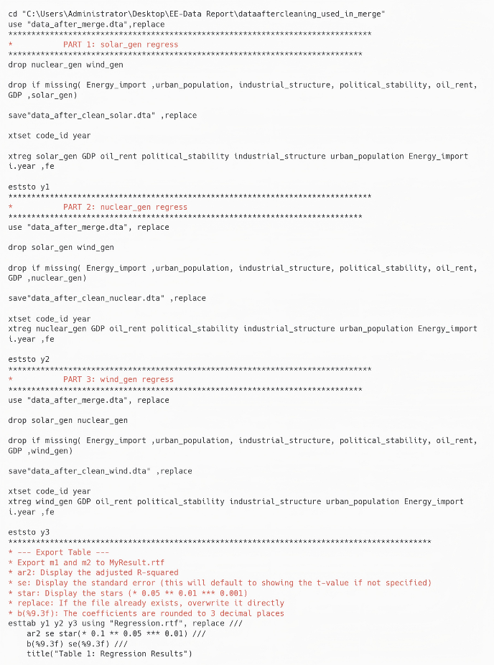The regression are with the dependent variable being Nuclear/Solar/Wind, the independent variable being GDP, and five control variables: oil rent, political stability, industrial structure, urban population, and Energy import.

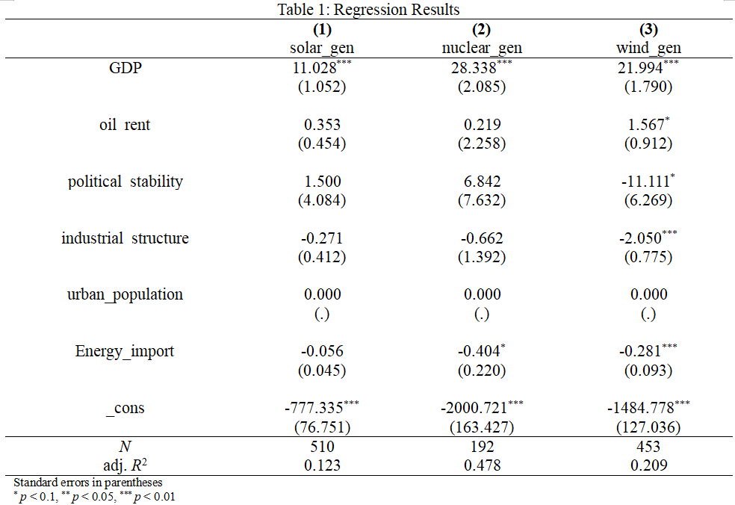**Figure 13**: Regression do-file (1) structure **Figure 14**: Regression do-file (2) structure

**Figure 15**: Regression results

The first two sections answer research question (QR) 2, while the regression is used to explain RQ 1. The regression results show that the coefficient of nuclear energy is the highest, at 28.3. The coefficient of wind energy is 21.9, and that of solar energy is 11. The differences in these coefficients indicate that (1) energy is highly sensitive to a country's economic situation. (2) Nuclear power requires a strong economy to operate effectively. In terms of the environmental Kuznets Curve (EKC), since the coefficients of the regressed GDP are all positive, this indicates that economic growth does indeed bring about a huge demand for energy, which is a technical effect. A positive GDP coefficient indicates that the larger the scale, the greater the demand for energy, the richer the wealth, and the country can choose energy with higher prices. Therefore, the threshold for nuclear energy is relatively high, while that for wind energy and solar energy is relatively low. The limitation of regression lies in that, due to collinearity, the urbanization rate is still closely related to GDP and thus is excluded. Furthermore, since only some variables are controlled, only correlations can be displayed, but not causal relationships.

**4. Part IV: Discussion and Conclusions**

**a. Key Findings Summary**

This study explores two research questions using visualization and regression analysis. The results indicate that nuclear energy currently possesses the largest power generation capacity among all energy sources; however, it requires a stronger economic foundation, meaning that nuclear energy is more difficult to market than wind and solar energy, thus limiting its capacity to a few wealthy countries. The study did not yield any unexpected conclusions and largely validates the research structure of previous scholars.

**b. Policy and Research Implications**

The research results indicate that countries face numerous challenges in transitioning nuclear energy to clean energy, particularly the need for substantial financial and technological support. It validates the core tenet of the EKC theory: only when the economy develops to a certain level will a country have the capacity and willingness to manage the environment, which means choosing expensive clean energy sources. Future research should integrate energy storage markets with the levelized cost of electricity (LCOE) of clean energy to enhance the assessment of power generation capacity. Furthermore, regression models analyzing the relationship between GDP and clean energy development can be strengthened by incorporating more control variables and expanding data coverage.

**c. Technical Reflection**

Although this study used global data, the sample size was limited due to missing reporting on electricity generation in some countries. Visualization techniques were used to aid in data aggregation, and regression analysis was employed to examine the relationship between GDP and different energy sources, while controlling for the effects of certain variables. The initial research question regarding cost-based energy transition was abandoned due to the lack of reliable data on the level of cost of nuclear power (LCOE). Nuclear generation costs differ widely due to variations in construction efficiency, financing conditions, regulatory frameworks, and the degree of government involvement (IEA, 2020; Lazard, 2023). Future research to fill this data gap will allow for a more comprehensive comparison of the economic benefits of nuclear and renewable energy.

**References:**

Github link: <https://github.com/MonanCai59/group_1>

Aghion, P., Dechezleprêtre, A., Hémous, D., Martin, R., & Van Reenen, J. (2016).

Carbon taxes, path dependency, and directed technical change: Evidence from the auto industry. Journal of Political Economy, 124(1), 1–51. <https://www.journals.uchicago.edu/doi/abs/10.1086/684581>

Dasgupta, S., Laplante, B., Wang, H., & Wheeler, D. (2002).

Confronting the environmental Kuznets curve. Journal of Economic Perspectives, 16(1), 147–168. <https://www.aeaweb.org/articles?id=10.1257/0895330027157>

Energy Institute (2025), Statistical Review of World Energy 2025, Energy Institute, London. [Data set] <https://www.energyinst.org/statistical-review/home>

Grossman, G. M., & Krueger, A. B. (1995).

Economic growth and the environment. Quarterly Journal of Economics, 110(2), 353–377. <https://academic.oup.com/qje/article-abstract/110/2/353/1826336>

IEA. (2020).

Projected costs of generating electricity 2020. International Energy Agency. <https://www.iea.org/reports/projected-costs-of-generating-electricity-2020>

IEA. (2021).

Hydropower special market report. International Energy Agency. <https://www.iea.org/reports/hydropower-special-market-report>

IEA. (2022).

Electricity market report. International Energy Agency.

<https://www.iea.org/reports/electricity-market-report-january-2022>

IEA. (2023).

World energy outlook 2023. International Energy Agency. <https://www.iea.org/reports/world-energy-outlook-2023>

IPCC. (2022).

AR6 Working Group III: Mitigation of climate change. Intergovernmental Panel on Climate Change. <https://www.ipcc.ch/report/ar6/wg3/>

IRENA. (2023).

Renewable power generation costs in 2022. International Renewable Energy Agency. <https://www.irena.org/Publications/2023/Aug/Renewable-Power-Generation-Costs-in-2022>

Joskow, P. L. (2011).

Comparing the costs of intermittent and dispatchable electricity generating technologies. American Economic Review, 101(3), 238–241. <https://www.aeaweb.org/articles?id=10.1257/aer.101.3.238>

Kriström, B., & Riera, P. (1996).

Is the income elasticity of environmental improvements less than one? Environmental and Resource Economics, 7(1), 45–55. <https://link.springer.com/article/10.1007/BF00420426>

Lazard. (2023).

Levelized cost of energy analysis—Version 16.0. Lazard Ltd. https://www.lazard.com/media/typdgxmm/lazards-lcoeplus-april-2023.pdf

Marques, A. C., & Fuinhas, J. A. (2012).

Is renewable energy effective in promoting economic growth? Energy Policy, 46, 434–442. <https://www.sciencedirect.com/science/article/pii/S0301421512002911>

MIT Energy Initiative. (2018).

The future of nuclear energy in a carbon-constrained world. Massachusetts Institute of Technology. <https://energy.mit.edu/wp-content/uploads/2018/09/The-Future-of-Nuclear-Energy-in-a-Carbon-Constrained-World.pdf>

Nature Energy. (2022).

The role of nuclear power in a low-carbon energy system. Nature Energy, 7, 107–115. <https://www.oecd-nea.org/upload/docs/application/pdf/2019-12/nea6887-role-nuclear-low-carbon.pdf>

OECD. (2021).

Effective carbon rates 2021. OECD Publishing. <https://www.oecd.org/en/publications/effective-carbon-rates-2021_0e8e24f5-en.html>

Sadorsky, P. (2009).

Renewable energy consumption and income in emerging economies. Energy Policy, 37(10), 4021–4028. <https://www.sciencedirect.com/science/article/pii/S0301421509003176>

Stern, D. I. (2004).

The rise and fall of the environmental Kuznets curve. World Development, 32(8), 1419–1439. <https://www.sciencedirect.com/science/article/pii/S0305750X04000798>

The World Bank. (2024). GDP per capita (current 2015 US$) [Data set]. <https://data.worldbank.org/indicator/NY.GDP.PCAP.KD>

The World Bank. (2024). Energy import, net (% of energy use) [Data set]. <https://data.worldbank.org/indicator/EG.IMP.CONS.ZS>

The World Bank. (2024). Political stability and absence of violence/terrorism [Data set]. <https://data.worldbank.org/indicator/PV.EST>

The World Bank. (2024). Urban population (% of total population) [Data set]. <https://data.worldbank.org/indicator/SP.URB.TOTL.IN.ZS>

The World Bank. (2024). Oil rent (% of GDP) [Data set]. <https://data.worldbank.org/indicator/NY.GDP.PETR.RT.ZS>

The World Bank. (2024). Oil rent (% of GDP) [Data set]. <https://data.worldbank.org/indicator/NV.IND.TOTL.ZS>

The World Bank. (2024). Industry (including construction), value added (% of GDP) [Data set]. <https://data.worldbank.org/indicator/NV.IND.TOTL.ZS>